Credit Card Default Prediction

Classification

Project Description

**Business Context**

This project is aimed at predicting the case of customers' default payments in Taiwan. From the perspective of risk management, the result of predictive accuracy of the estimated probability of default will be more valuable than the binary result of classification - credible or not credible clients. We can use the [K-S chart](https://www.listendata.com/2019/07/KS-Statistics-Python.html) to evaluate which customers will default on their credit card payments.

**Dataset Description**

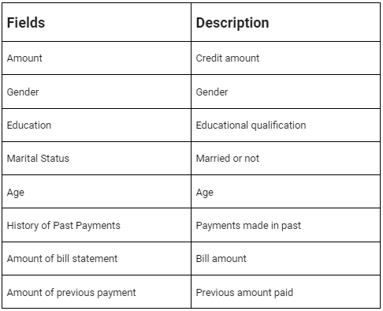

**Main Libraries used:**

* Pandas for data manipulation, aggregation
* Matplotlib and Seaborn for visualization and behavior with respect to the target variable
* NumPy for computationally efficient operations
* Scikit Learn for model training, model optimization, and metrics calculation

**Project Architecture:**

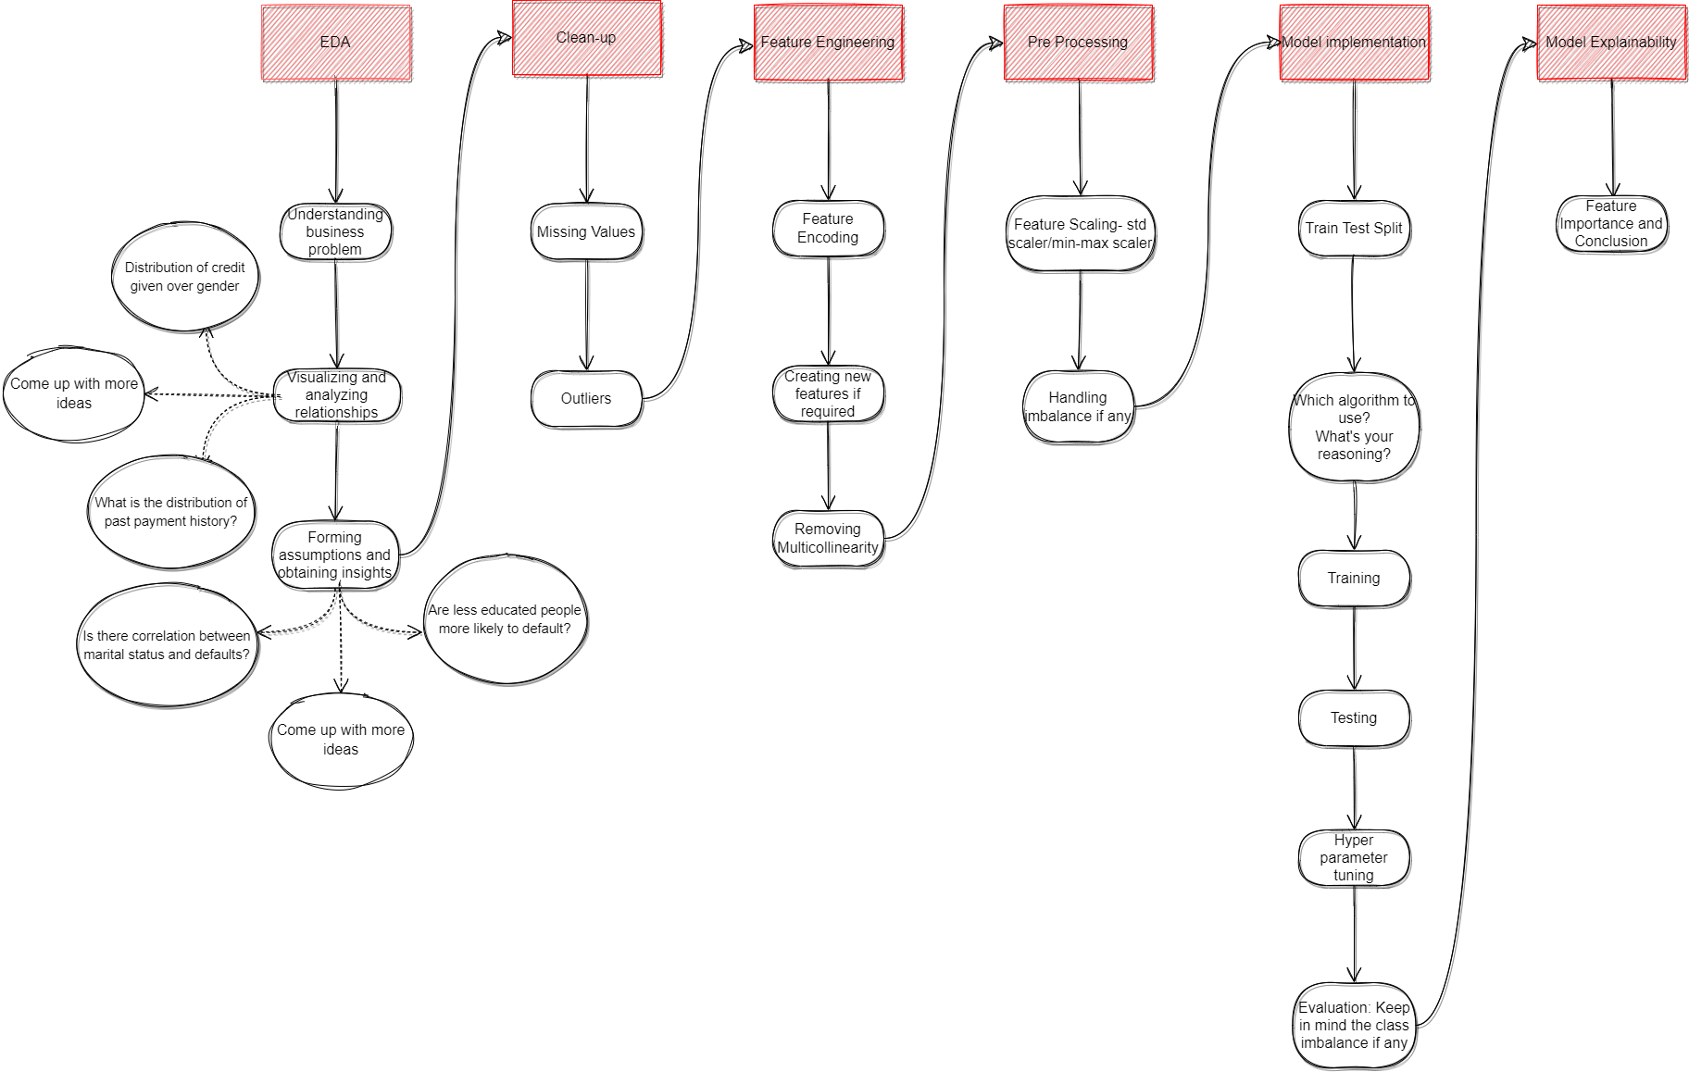

Help